Map Reduce Types and Formats

MapReduce types
- map: (k1, v1) -> list(k2, v2)
- combine: (k2, list(v2)) -> list(k2, v2)
- reduce: (k2, list(v2)) -> list(k3, v3)
Context objects are used for emitting key-value pairs. While it's good to match map output with reduce input, it's not enforced by the Java compiler
The partition operates on the intermediate key and value types (k2 and v2) and returns the partition index.
Input types are set by the input format, the other types are set in the Job. If not set, the intermediates types default to the final output types, so if k2 and k3 are the same there is no need to call setMapOutputKeyClass(). Some must be set because some in some aspects the type can be checked at compile time.

The default MapReduce Job
public int run(String[] args) throws Exception {
Job job = JobBuilder.parseInputAndOutput(this, getConf(), args);

job.setInputFormatClass(TextInputFormat.class);

job.setMapperClass(Mapper.class);

job.setMapOutputKeyClass(LongWritable.class);
job.setMapOutputValueClass(Text.class);

job.setPartitionerClass(HashPartitioner.class);

job.setNumReduceTasks(1);

job.setReducerClass(Reducer.class);

job.setOutputKeyClass(LongWritable.class);
job.setOutputValueClass(Text.class);

job.setOutputFormatClass(TextOutputFormat.class);

return job.waitForCompletion(true) ? 0 : 1;
}
We set the input format as TextInputFormat which produces LongWritable (current line in file) and Text values. The integer in the final output is actually the line number. The map is the default Mapper that writes the same input key and value, by default LongWritable as input and Text as output.
The partitioner is HashPartitioner that hashes the key to determine which partition belongs in. There are as many partitions as reducers and we have only one in the default but if not all records will be evenly allocated across reduce tasks and they will share the same key.
The number of map tasks is equal to the number of splits that the input is turned into. The number of reducers will be equal to the number of nodes multiplied by the slots per node mapred.tasktracker.reduce.tasks.maximum. It it's good to have slightly fewer reducers than total slots.
The output key is LongWritable and the output value is Text. Records are sorted before the reducer.

The default Streaming Job
$ hadoop jar $HADOOP_INSTALL/contrib/streaming/hadoop*-streaming.jar \
-input input/sample.txt \
-output output \
-mapper /bin/cat
There is not default identity mapper so it must explicitly be set. Hadoop Streaming output keys and values are always Text. Usually the key (the line offset) is not passed to the mapper. The default command set explicitly is:
$ hadoop jar $HADOOP_INSTALL/contrib/hadoop-*streaming.jar \
-input input/sample.txt \
-output output \
- inputformat org.apache.hadoop.mapred.TextInputFormat \
-mapper /bin/cat \
-partitioner org.apache.hadoop.mapred.lib.HashPartitioner \
-numReduceTasks 1 \
-reducer org.apache.hadoop.mapred.lib.IdentityReducer \
-outputformat org.apache.hadoop.mapred.TextOutputFormat

Keys and Values in Streaming
A Streaming app can control the separator used when a key-value pair is turned into a series of bytes (defaults is tab char)
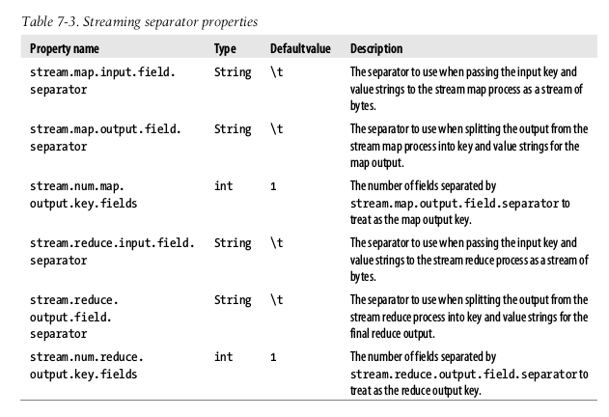
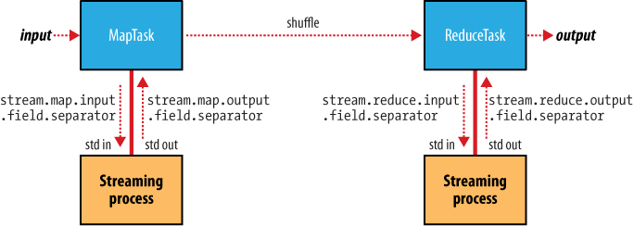

Input formats

InputSplits and Records
Each map processes a split that is divided into records. A client running a job calls InputFormat.getSplits() to retrieve the InputSplit list that is sent to the JobTracker to scheduling. On a TaskTracker the map passes the split to InputFormat.createRecordReader() to obtain the RecordReader (that is a iterator). The Map run() method:
public void run(Context context) throws IOException, InterruptedException {
setup(context);
while (context.nextKeyValue()) {
map(context.getCurrentKey(), context. getCurrentValue(), context);
}
cleanup(context);
}
run() method is public and may be customized.

FileInputFormat
Base class of InputFormat for files. The input is a collection of input paths (file, directory or both)
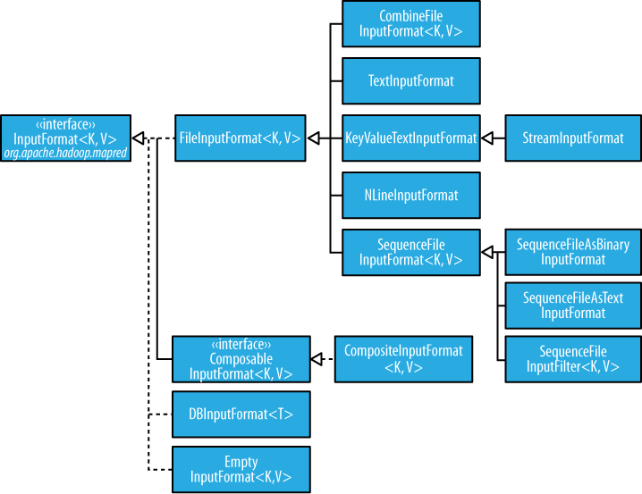

To exlude certain files from the input, you can use setInputPathFilter(), by default it excludes hidden files.

FileInputFormat input splits
FileInputFormat splits files over the HDFS block size. You could also set a min and max size.

Small files and CombineFileInputFormat
CombineFileInputFormat packs many small files into each split. It also takes into account the node and rack locality.
You could also use a SequenceFile: keys are filenames and values file contents.

Preventing splitting
Some apps don't want files to be split, to avoid it you can increase the min split size to be larger than the largest file or subclass FileInputFormat to override the isSplittable() to return false.

File information in the mapper
A mapper processign a file input split can find information about the split by calling the getInputSplit() on Mapper's Context object

Processing a whole file as a record
First, avoid file splitting and to have a RecordReader that delivers the file contents as the value of the record.

Text Input

TextInputFormat
Each record is a line of input. The key, a LongWritable is the byte offset (not line number) within the file of the beginning of the line.

KeyValueTextInputFormat
To interpret text files where the key needs to be something different than the line offset. For example, a file with key-values separated by commas:
a,2
a,3
b,1
You can specify the separator (the comma) via the mapreduce.input.keyvaluelinerecordreader.key.value.separator

NLineInputFormat
To send a fixed number of lines to the mapper use NLineInputFormat

XML
StreamXMLRecordReader is used, setting the input format to StreamInputFormat and the stream.recordreader.class property to org.apache.hadoop.streaming.StreamXmlRecordReader

Binary Input

SequenceFileInputFormat
The common way is to call SequenceFileInputFormat that will delivers the corresponding key-values, like IntWritable:Text but a casting is possible that it delivers only Text:Text with SequenceFileAsTextInputFormat or BytesWritable objects with SequenceFileAsBinaryInputFormat

Multiple Inputs
All of the inputs is interpreted by a single InputFormat and a single Mapper. But when you have different inputs you must use the MultipleInputs class that allows to use the InputFormat and Mapper on a per-path basis.

Database Input (and output)
DbInputFormat is for reading RDBS using JDBC. DbOutputFormat is for dumping the results to a DDBB.
TableInputFormat is used to read from HBase.

Output Formats
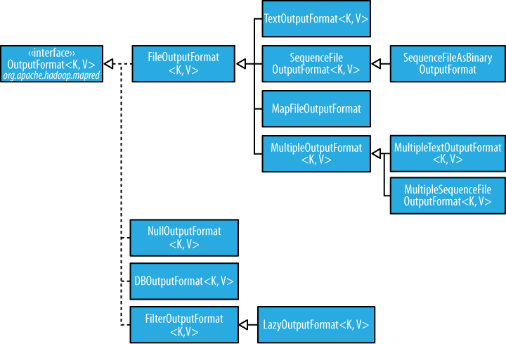

Text Output
The default TextOutputFormat writes records as lines of text tab-separated (that can be changed using mapreduce.output.textoutputformat.separator) calling to the toString() method on each record.

Binary Output

SequenceFileOutputFormat, SequenceFileAsBinaryOutputFormat and MapFileOutputFormat
The two classes are to create SequenceFile files, with and without compression. MapFileOutputFormat is to write MapFiles.

Multiple Outputs
For example, We will consult data from weather stations we would like to have a file for each station. To do this we need MultipleOutputs to write data to files whose names are derived from the output keys and values calling the MultipleOutputs.write() in the reducer instead of the Context.

LazyOutput
FileOutputFormat will create output (part-r-nnnnn) files even if they are empty. LazyOutput is used to avoid this.

Unit Test MapReduce using MRUnit

In order to make sure that your code is correct, you need to Unit test your code first. And like you unit test your Java code using JUnit testing framework, the same can be done using MRUnit to test MapReduce Jobs.
MRUnit is built on top of JUnit framework. So we will use the JUnit classes to implement unit test code for MapReduce. If you are familiar with JUnits then you will find unit testing for MapReduce jobs also follows the same pattern.
I will now discuss the template that can be used for writing any unit test for MapReduce job.
To Unit test MapReduce jobs:
- Create a new test class to the existing project
- Add the mrunit jar file to build path
- Declare the drivers
- Write a method for initializations & environment setup
- Write a method to test mapper
- Write a method to test reducer
- Write a method to test the whole MapReduce job
- Run the test

Create a new test class to the existing project
I’ll use the WordCount example to demonstrate unit testing. First create a new class with the name “TestWordCount” in the existing wordCount project.
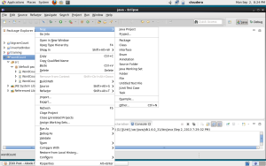
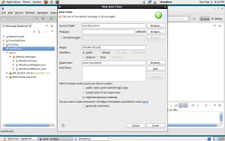

Add the mrunit jar file to build path
Download the latest mrunit jar file from http://apache.cs.utah.edu/mrunit/mrunit-1.0.0/. Unzip the folder and you will find mrunit jar file inside the lib directory. We need to add that jar to the build path.
Right click on the project and click on “Properties”.
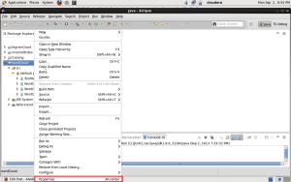
Click on Add external Jar file and add the jar file you recently downloaded.
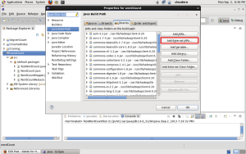

Declare the drivers
Instead of running the actual driver class, for unit testing we will declare drivers to test mapper, reducer and the whole MapReduce job.

1  2  3 | MapDriver<LongWritable, Text, Text, IntWritable> mapDriver;  ReduceDriver<Text, IntWritable, Text, IntWritable> reduceDriver;  MapReduceDriver<LongWritable, Text, Text, IntWritable, Text, IntWritable> mapReduceDriver;

Note that you need to import the following:

1  2  3 | import org.apache.hadoop.mrunit.mapreduce.MapDriver;  import org.apache.hadoop.mrunit.mapreduce.MapReduceDriver;  import org.apache.hadoop.mrunit.mapreduce.ReduceDriver;

and not

1  2  3 | import org.apache.hadoop.mrunit.MapDriver;  import org.apache.hadoop.mrunit.MapReduceDriver;  import org.apache.hadoop.mrunit.ReduceDriver;

As the word count mapper takes LongWritable offset and Text of line, we have given the same as the generic parameters of the mapDriver. Same is the case with the reduceDriver and mapReduceDriver.

Write a method for initializations & environment setup
This is the code that runs before any (and every) test runs and can be used for all the initializations that you want to do. You will need to add @Before annotation before this method.

1  2  3  4  5  6  7  8  9  10  11  12  13  14  15 | @Before  public void setUp()  {  WordCountMapper mapper = new WordCountMapper();  mapDriver = new MapDriver<LongWritable, Text, Text, IntWritable>();  mapDriver.setMapper(mapper);  WordCountReducer reducer = new WordCountReducer();  reduceDriver = new ReduceDriver<Text, IntWritable, Text, IntWritable>();  reduceDriver.setReducer(reducer);  mapReduceDriver = new MapReduceDriver<LongWritable, Text, Text, IntWritable, Text, IntWritable>();  mapReduceDriver.setMapper(mapper);  mapReduceDriver.setReducer(reducer);  }

In the first three lines of the above code, we create an object of the mapDriver and set the mapper for the driver. Note that we are not setting the reducer class. It is because the mapDriver will only test the mapper logic.
Similarly we set the reducer class to the reduceDriver. However, when we want to test the MapRedcue job as a whole, we need to test both the mapper and the reducer. Therefore we need to set both the mapper and reducer class to the mapReduceDriver.

Write a method to test mapper
To declare a method as a test method it must be annotated with @Test.

1  2  3  4  5  6  7  8  9 | @Test  public void testMapper() throws IOException  {  mapDriver.withInput(new LongWritable(1), new Text("orange orange apple"));  mapDriver.withOutput(new Text("orange"), new IntWritable(1));  mapDriver.withOutput(new Text("orange"), new IntWritable(1));  mapDriver.withOutput(new Text("apple"), new IntWritable(1));  mapDriver.runTest();  }

The mapDriver takes as input a LongWritable and a Text “apple orange orange” in the form of key value pair. We want out wordCountMapper to output each word as key and “1” as the value. So we set the output of the driver accordingly. Finally runTest method runs the mapDriver.

Write a method to test reducer
In the wordCount example, we get a word and list of IntWritable values (all 1’s) associated with it. The reducer code is then supposed to give the final ouput with word as key and its count as value. To test the reducer functionality we use the code given below.

1  2  3  4  5  6  7  8  9  10 | @Test  public void testReducer() throws IOException  {  List values = new ArrayList();  values.add(new IntWritable(1));  values.add(new IntWritable(1));  reduceDriver.withInput(new Text("orange"), values);  reduceDriver.withOutput(new Text("orange"), new IntWritable(2));  reduceDriver.runTest();  }

Write a method to test the whole MapReduce job
In order to test the complete MapReduce job, we give the input offset as key and line of text as value to the mapReduceDriver. And the final output is supposed to be the word as key and its count as the value. We therefore set addInput and addOutput appropriately.

1  2  3  4  5  6  7  8 | @Test  public void testMapperReducer() throws IOException  {  mapReduceDriver.addInput(new LongWritable(1), new Text("orange orange apple"));  mapReduceDriver.addOutput(new Text("orange"), new IntWritable(2));  mapReduceDriver.addOutput(new Text("apple"), new IntWritable(1));  mapReduceDriver.runTest();  }

Run the test
To run the test, right click on the class “TestWordCount” and goto “Run as” and select “Junit Test”.
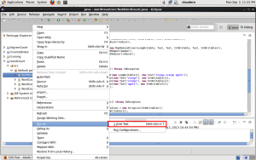
If the mapper, reducer and mapReduce job as a whole is correct, then you should get an output where you see no errors or failures.
